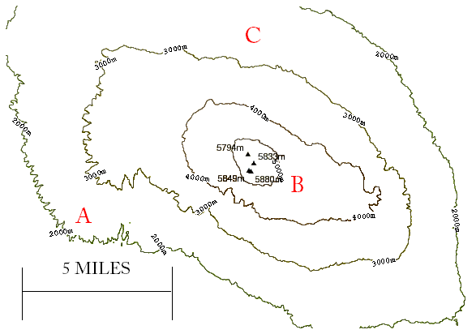

- Make an estimate of the distance between A and B.
_______________________________________

- What is the highest point on Mt. Kilimanjaro?
_______________________________________

- Drawing on the map, give the ideal route from A - C
Explain why you chose that route. _________________________________________

